Output Voltage

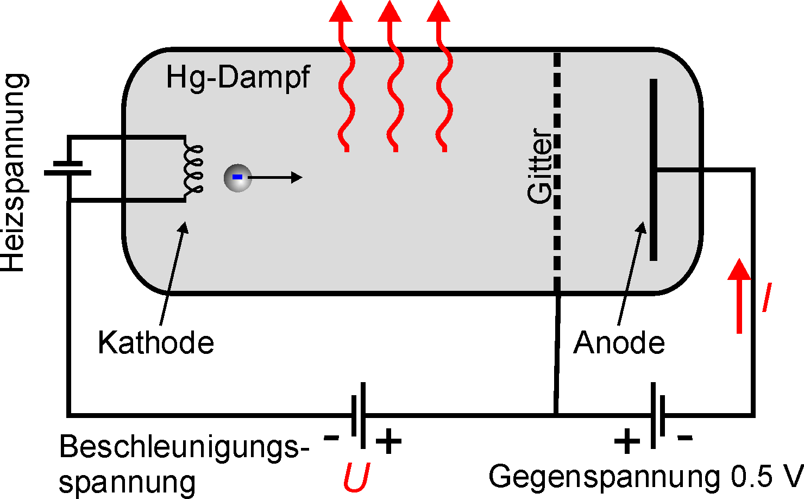

Retarding Voltage

Accelerating Voltage (variable)

Filament Voltage

Cathode

Grid

Hg - Heated

Output Current

Control Box

Keithly 2100 Multi-meter 1

Keithly 2100 Multi-meter 2

Computer

Function Generator

Lock-In Detector